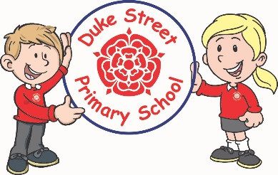
Duke Street Primary School – Home Learning Tasks Year 2

Dear Parent/Carer,
Please find attached a selection of home learning tasks that your child can complete during the first 2 weeks of our forced school closure. Following this, more work will be sent out weekly, should the school remain closed after the Easter Holidays. We have designed these tasks so that they can be completed independently, with the exception of some of the reading tasks. Some tasks are a one off, others are to be completed as often as possible.
Some tasks may require internet access for online activities or research. Others are more open ended so that the children can choose how they would like to present their work. The tasks can be done in any order.
There is a grid attached for you to date when tasks have been complete and add any comments you may want to.
If your child would like to send a photograph of anything they have created for me to see, they can do so via the class email address which is redwood@dukestreet-pri.lancs.sch.uk
Thank you in anticipation of your support
Mr Reay
Class Teacher

Task 1: Maths  Log on to your Numbots/TTRS account and complete at least 10 minutes of questions each day.  Numbots: How many coins can you earn?  TTRS: Can you ‘level up’? | Task 2: Maths  Practice arithmetic skills by completing Early Bird Maths questions each day. The questions and answers will be sent by email. | Task 3: Reading  Read for 10 minutes, at least 3 times a week. This can be from any book that you have at home,  Remember to ask an adult to sign your reading planner every time you read. | Task 4: Reading  Log in to the reading cloud and blog about a story you have read.  www.readingcloud.net  Did you enjoy the story? Why/why not?  What was your favourite part?  Who was your favourite character?  What was the story about? | Task 5: Spellings  Practice reading and writing your spelling words.  Try putting these words into sentences.
Task 6: Phonics  Access the free Phase 5 and Phase 6 phonics games on www.phonicsplay.co.uk  Access some Year 2 grammar worksheets on twinkl, about sentences and conjunctions (and, but, because, if, so) | Task 7: Geography  Use the internet to research and write at least 6 interesting facts about Amundsen and his Antarctic Expedition. | Task 8: Science  Find and observe the wildlife in your garden, including plants, mini beasts, birds and other animals.  Can you draw and label your garden habitat? | Task 9: PSHE  Design a poster explaining how to stay safe online.  This can be done by drawing on paper or completed in a word document.  This should include 3 rules for keeping safe online. | Task 10:  Write a story about your own animal character.  Access educationquizzes.com click on KS1 and complete English and Maths quizzes.

Task | Date Completed | Any comments
1 | Daily
2
3
4
5
6
7
8
9
10

